How visible and readable do you feel each of the following are on the Application - [Link](https://app.uizard.io/p/d82ceb8b)

Ranking: 8 / 10



Comments: Clear to see and well spaced. Easily understood

Ranking: 10 / 10

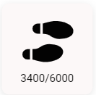

Comments: Icon makes it very easy to understand

Ranking: 6 / 10



Comments: Took time to figure out what icon was

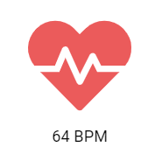

Ranking: 9 / 10

Comments: Heart easy to understand

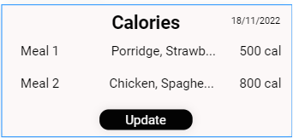

Ranking: 10 / 10

Comments: Easily tracked throughout the day as rings fill

Ranking: 7 / 10



Comments: Not eye catching but easy to understand